R Markdown in-class

Billy Lozowski

2025-02-27

Table of Contents

[→ Noel et al. (2022) article ←](https://doi.org/10.1094/PDIS-06-21-1253-RE)

### DON (ppm) x Treatment

p1 <- ggplot(mycotoxin, aes(Treatment, DON, fill = Cultivar)) + # set plot mapping  
 geom_boxplot(position = position_dodge(0.85), outlier.shape = NA) + # dodge the boxplots + hide outliers  
 geom_jitter(shape = 21, width = 0.3, alpha = 0.6) + # set point shape, dodge width, and transparency  
 scale_fill_manual(values = c(cbbPalette[(3)], cbbPalette[(4)])) + # specify fill colours  
 labs(x = "", # define labels  
 y = "DON (ppm)") +  
 theme_classic() +  
 facet_wrap(~Cultivar) # separate plots by Cultivar  
  
P1 <- p1 +   
 stat_compare_means(method = "anova") +   
 geom_pwc(aes(group = Treatment), # specify which means you want to compare  
 method = "t.test",  
 label = "{p.adj.format}{p.adj.signif}")  
P1

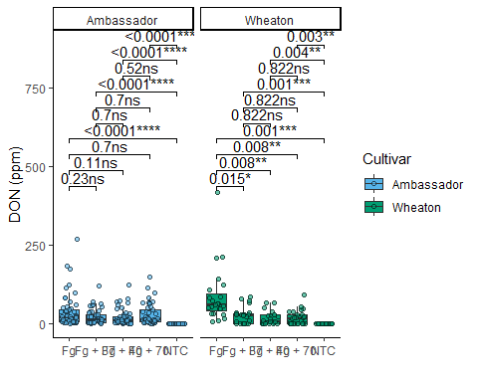

### X15ADON x Treatment

p3 <- ggplot(mycotoxin, aes(Treatment, X15ADON, fill = Cultivar)) + # mapping  
 geom_boxplot(position = position_dodge(0.85), outlier.shape = NA) + # boxplot mapping  
 geom_jitter(shape = 21, width = 0.3, alpha = 0.6) + # jitter mapping  
 scale_fill_manual(values = c(cbbPalette[(3)], cbbPalette[(4)])) + # fill colours  
 labs(x = "", # labels  
 y = "15ADON") +  
 theme_classic() +  
 facet_wrap(~Cultivar) # separate plots  
  
P3 <- p3 +  
 stat_compare_means(method = "anova") +   
 geom_pwc(aes(group = Treatment), # specify which means you want to compare  
 method = "t.test",  
 label = "{p.adj.format}{p.adj.signif}")  
P3

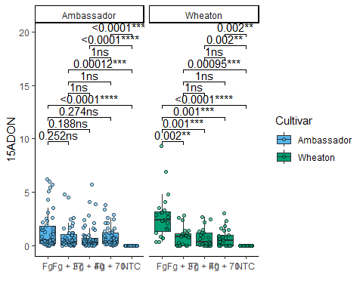

### Seed Mass x Treatment

p4 <- ggplot(mycotoxin, aes(Treatment, MassperSeed_mg, fill = Cultivar)) + # mapping  
 geom_boxplot(position = position_dodge(0.85), outlier.shape = NA) + # boxplot mapping  
 geom_jitter(shape = 21, width = 0.3, alpha = 0.6) + # jitter mapping  
 scale_fill_manual(values = c(cbbPalette[(3)], cbbPalette[(4)])) + # fill colours  
 labs(x = "", # labels  
 y = "Seed Mass (mg)") +  
 theme_classic() +  
 facet_wrap(~Cultivar) # separate plots  
  
P4 <- p4 +  
 stat_compare_means(method = "anova") +   
 geom_pwc(aes(group = Treatment), # specify which means you want to compare  
 method = "t.test",  
 label = "{p.adj.format}{p.adj.signif}")  
P4

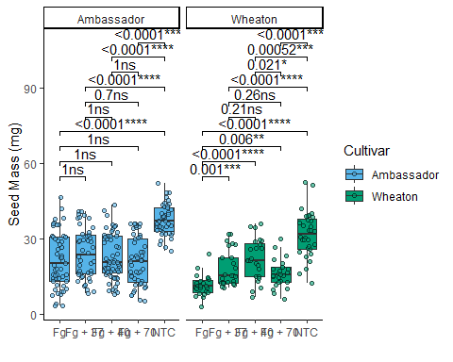

### Combined plot with ‘ggarrange’

# arrange plots + stats in combined figure  
fig2 <- ggarrange(  
 P1, P3, P4, # select plot objects  
 labels = "auto",  
 nrow = 1,  
 ncol = 3,  
 legend = FALSE # remove legend  
)  
fig2

